COMP 354 Deliverable #3 – Improved functionality, Integration and technical debt
Due Date: Document 12/4/2022 at 23.55
For the deliverable of iteration #2 provide an implementation/testing document which contains the following info:
All parts are performed as a group, meaning every group member has to participate in all parts:
- Log indicating clearly the contribution of each member.
Best approach
Group member | Contribution
XYZ (+ Student-id if you have it) | - In terms of coding  - In terms of integration  - Other tasks performed for this deliverable  - Preparation of the document
zab (+ Student-id if you have it) | - In terms of coding  - In terms of integration  - Etc…  - Preparation of the document
Functionality
Similar to the previous document, however the focus is on changes since the last document in terms of
Any new major libraries/components you used. => if no special 3rd party or major API used, just mention not applicable or if no change since the last deliverable
Also if you get some larger code fragments make a reference to the stack overflow post. No worries. You are not loosing points for using external resources, it is actually encouraged !
- Functional testing – since the last deliverable
  - Clearly indicate which functionality has been added, fixed, improved since the last deliverable
  - Clearly indicate which functionality has been currently omitted or is only partially working (specify what is working/not working).
- Indicate also the major changes between the last deliverable (deliverable #2) and your current implementation (deliverable #3) – in terms of design changes + features implemented.
- Screen captures showing the major new features implemented (or changes to previous features) – please document each screen capture with 1-2 sentences

Integration
The goal should be to get the complete app on the phone working as well as the web interface.
At the minimum, I would like to see the integration attempt with at least one other group. If you can establish the data and control flow through multiple groups even better (bonus points) – see point 2 below.
- Please specify the group you were trying to attempt to integrate with
Group integrated with:
Outcome: Successful/Unsuccessful
Challenges: Briefly mention some of the main challenges and if you were able to resolve them (+ how) – does not have to be long. Just a few sentences.
2. If you were part of a multi group integration, please specify which groups other groups were successfully integrated. You could just use a chart like below, which could actually be shared among the groups which successfully integrated.
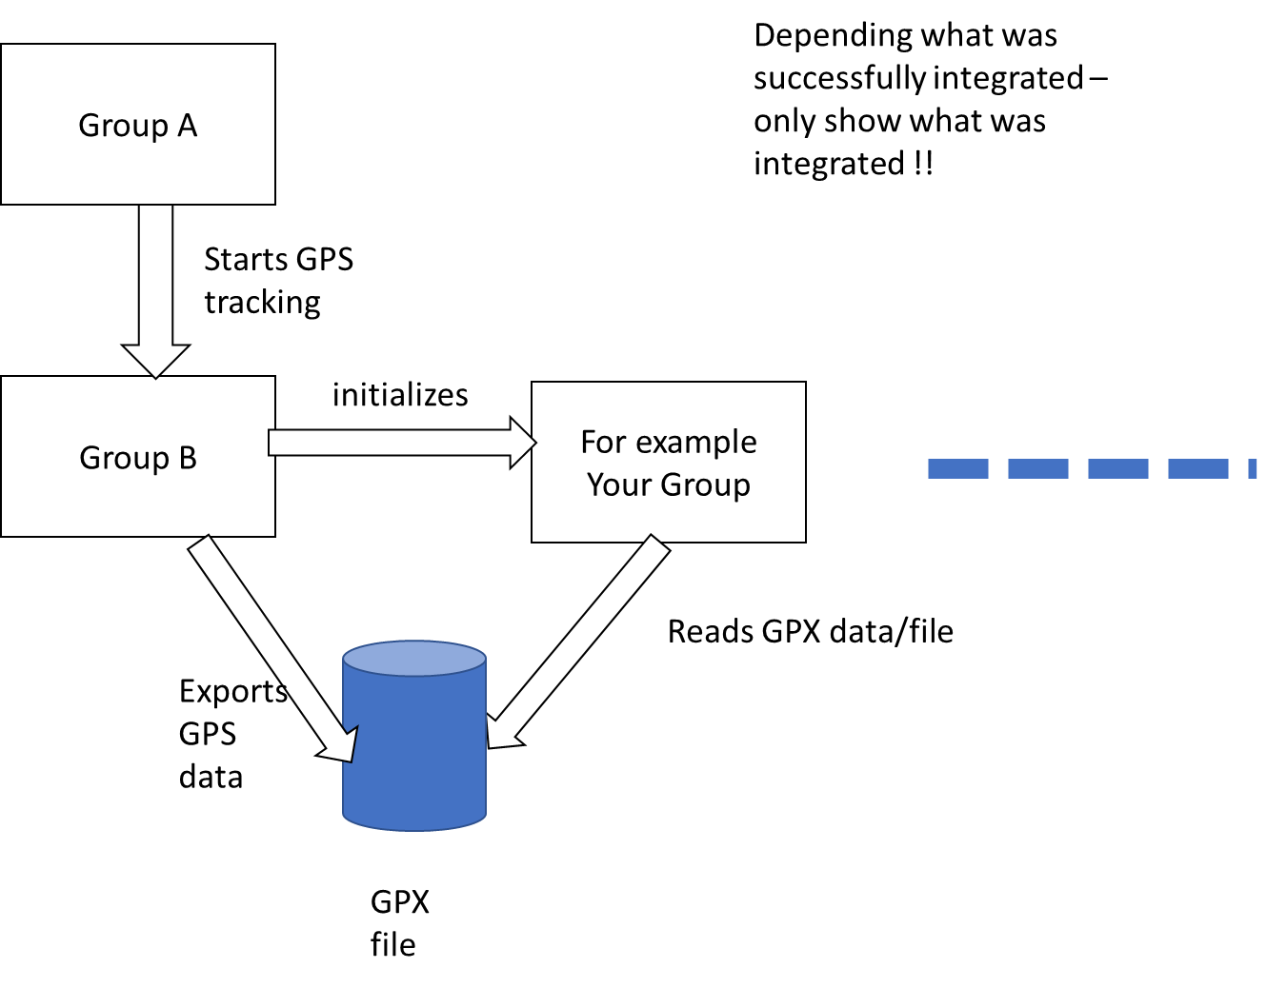
Technical debt section
Computing technical Debt with SonarQube – Community Edition (https://www.sonarqube.org/downloads/
Important: Do not spend more than a maximum of 3 hours.

Helpful link:
https://duecode.io/blog/what-is-technical-debt-in-sonarqube/
Deliverable:
- Analyze your groups code using SonarQube
- Report the technical debt for the project you analyzed
Group name:
Screen captures of technical debt reported for your component. Below are the things you could include as part of your submission. These reports might have changed with the latest version of SonarQube
- In case you were unable to run SonarQube – mention where you got stuck.
Last but not least : Link to the source code on project GitHub repository.
Important:
Make sure that you address all of these points, because they become my evaluation criteria. If something is not applicable to you – state clearly that it is not applicable.
Do not forget the link to the source code on GitHub
Only one submission per group –

